Bristol City College Poems for BAC 100

Flying by Donald

Flying
Flying can be fun
Flying can be great
Flying can be hard to do

Flying can be fun
Flying can be scary
Flying can be hard to do
Flying can make you free

Flying can be scary
Flying can make you sick
Flying can make you free
Flying can make you feel so super

Flying can make you sick
Flying can be great
Flying can make you feel super
Flying

Fluttering by Noelle

Fluttering
Time flies by
Heart beat quicken
Eyes get closer

Time flies by
As it passes so slowly
Distance gets closes
Lives left behind

As it passes so slowly
Changes continue
Lives left behind
Time continues to fly by

Changes continue
Heart beat quicken
Time continues to fly by
Fluttering

In the Air by Aaron and Francesco

Wings flying high
Deep into the sky
Gliding to the side
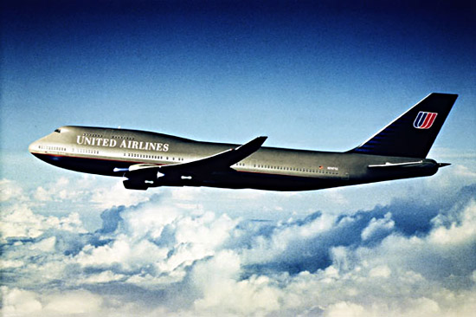
This aint no joy ride

Deep into the sky
Losing sight, feeling a bite
This aint no joy ride
Not gonna hide, riding the tide

Losing sight, feeling a bite
Launch a missile, hang on tight
Not gonna hide, riding the tide
Enemies aim is to kill the pride

Launch a missile, hang on tight
Gliding to the side
Enemies aim is to kill the pride
Wings flying high

British Airways by Gary

Coming in low
The glitter on the water
Sky scrapers
Landing smoothly like an air glider

The glitter on the water
Reflections of the sun
Landing smoothly like an air glider
Starting my holidays

Reflections of the sun
Billboards and yellow cabs
Starting my holidays
Dolphins so smooth

Billboards and yellow cabs
Skyscrapers
Dolphins so smooth
Coming in low

Changing by Chris

Changing
Of autumn leaves
Pretty
Brown, red, yellow

Of autumn leaves
They float through the air
Brown, red, yellow
Like a person in a plane

They float through the air
The sun is shining
I’m feeling happy
Like a bird in the sky

The sun is shining
Pretty
Like a bird in the sky
Changing

Soar

Soar
Icarus dreamt
To reach the sun
Glory of the shining heights

Icarus dreamt
Waxen wings leapt
Glory of the shining heights
Father and son in Concorde

Waxen wings leapt
When will he arrive?
Father and son in Concorde
Up, up he went

When will he arrive?
To reach the sun
Up, up he went
Soar

The Bullet by Nathan Smith-Cullo

The bullet
Flying through the air
Better duck or you will die
Blood splattered everywhere

Flying through the air
Smoking A K shells just there
Blood splattered everywhere
Brains scatter flying through the sky

Smoking AK shells just there
Smoke from the gun makes the vision blurred
Brains scatter flying through the sky
Blood shed from

Smoke from the gun makes the vision blurred
Better duck or you will die
Blood shed from
The bullet

The land of high cholesterol by Brian

Destination
I’m excited
Longing for sun
Hoping for no turbulence

I’m excited
Endless horizon
Hoping for no turbulence
Cramped in like battery chicken

Endless horizon
Basking in the warmth from the horizon
Cramped in like battery chicken
Cringing at the sight of the plastic tray

Basking in the warmth from the horizon
Longing for sun
Cringing at the sight of the plastic tray
Destination: the land of high cholesterol

One Balloon

One balloon
A sky full of balloons
A summer full of colour
Bristol

A sky full of balloons
And me looking up
Bristol
In the summer

And me looking up
Craning my neck
Counting the balloons
Wishing

Craning my neck
A summer full of colour
Wishing
One balloon …..

Take off by Chris

Take off
I love take off best
Travelling hopefully
Adventure ahead

I love take off best
Power of the engine
Adventure ahead
Flying away

Power of the engine
Off along the runway
Flying away
Towards the blue

Off along the runway
Travelling hopefully
Towards the blue
Take off!

Silver City by Yvonne

Silver City rumbling
High in the sky
Shining wings are glittering
* *
The body shakes and rattles
The noise loud and deafening
But no music is heard
* *
Over the water to foreign lands
Shaking and shivering
Wings dipping and plunging
* *
On board
The precious cargo awaits
In anticipation and expectancy
* *
The landing is hard
People and cars unload
Dispersing to places in the sun

Small plane by Betty
It was a new plane
I’ve been on a small plane
When the plane was flying along
I closed my eyes.
The man said ‘Open your eyes
And look at the clouds.’
I opened my eyes and looked at the clouds.
I was surprised when I opened my eyes
And looked out the window and seen the clouds
I enjoyed the flight.
I would like to go on a big aeroplane.

Tardis by Simon

Tardis is an anagram
Time and relative dimensions in space
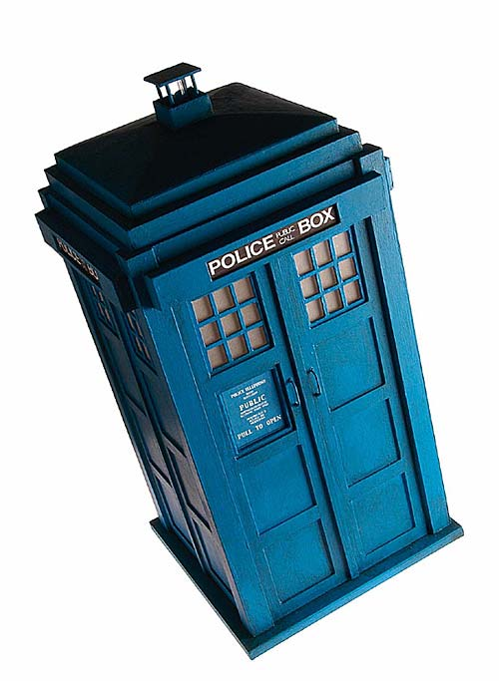
It’s stuck in the shape of an old blue police box
It travels through time and space

Time and relative dimensions in space
It’s bigger on the inside than it is on the outside
It travels through time and space
It lands on other planets and times

It’s bigger on the inside than it is on the outside
They meet other races and species like Daleks, Cybermen
It lands on other planets and times
Like the big bang

They meet other races and species like the Daleks and Cybermen
It’s stuck in the shape of an old blue police box
Like the big bang
Tardis is an anagram

Lift by Brian

The intoxication of the wing
To feel like a falcon soaring over the plains
The anticipation of the updraft
Never having the worry of the minions below

To feel like a falcon soaring over the plains
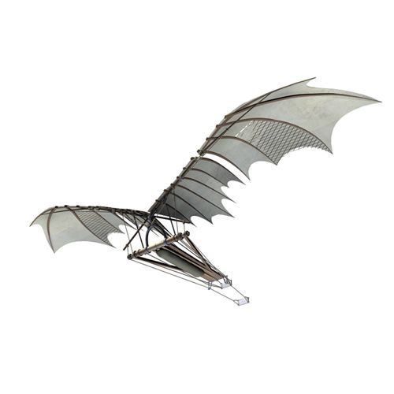
Knowing nothing in the sky can touch you
Never having the worry of the minions below
The warmth of the sun on my wings

Knowing nothing in the sky can touch you
Turbulence becomes a game of dodge
The warmth of the sun on my wings
The majesty of the sunset from 20,000 feet

Turbulence becomes a game of dodge
The anticipation of the updraft
The majesty of the sunset from 20,000 feet
The intoxication of the wing

Concorde by Nigel

Concorde test flights
About 1969
When she took off it was raining mist off the wings
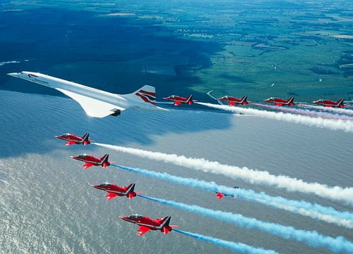
Dream come true

About 1969
Just left school, starting work
A dream come true
There was lager louts / football hooligans

Just left school, starting work
To buy a Bristol Cooper is a waiting list
There was lager louts / football hooligans
The last time I did see a Bristol Cooper was about 30 years

To buy a Bristol Cooper is a waiting list
When she took off it was raining mist off the wings
The last time I did see a Bristol Cooper was about 30 years
Concorde test flight

Concorde by Peter

Dreamy student days
Summer, blue skies, freshly cut grass
Anything possible in a friendly world
Staring up at Concorde high overhead

Summer, blue skies, freshly cut grass
Dozing in the afternoon sunshine
Staring up at Concorde high overhead
Technology at our service

Dozing in the afternoon sunshine
Confident the world is getting better
Technology at our service
Surely everything must work out well

Confident the world is getting better
Anything possible in a friendly world
Surely everything must work out well
Dreamy student days

Ballooning by Claire

Big balloon, candy striped, roaring
climbing high, cold in the sky
feeling fear but exciting
barking dogs and children waving

climbing high, cold in the sky
passing gardens, houses – speeding
barking dogs and children waving
over fields, grass, trees greening

passing gardens, houses – speeding
looking small – cows not caring
over fields, grass, trees greening
then coming down, fearful, crashing

looking small – cows not caring
feeling fear but exciting
then coming down, fearful, crashing
big balloon, candy striped, roaring

Planes by Tina

I like travelling
I like waiting in the airport
I don’t like air, it makes me cold, cold
On the plane

I like waiting in the airport
I don’t like flying down
On the planes
I don’t like landing

I don’t like flying down
My ears pop
I don’t like landing
I don’t like collecting the luggage

My ears pop
I don’t like air, it makes me cold, cold
I don’t like collecting the luggage
I like travelling

Take off and landing by Stacey
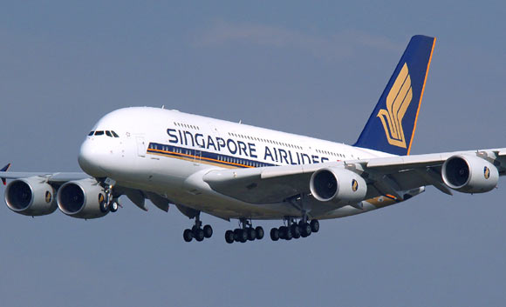
I don’t like taking off
But I am fine in the sky
I find it easier to sleep
The air conditioning is so cold

But I am fine in the sky
Their trolley hits my seat
The air conditioning is so cold
You can buy stuff on the plane

Their trolley hits my seat
It can be nice
You can buy stuff on the plane
You land with a bit of a bump

It can be nice
I find it easier to sleep
You land with a bit of a bump
I don’t like taking off

