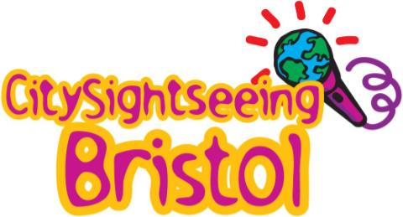 | 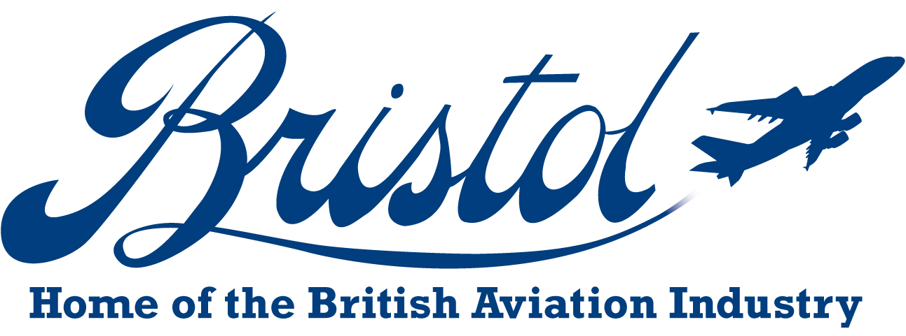
Guided ‘aviation’ tours of Bristol
(in conjunction with Bristol City Museum’s BAC 100 exhibition)
Sat 18th and Sun 19th September, and Sat 27th and Sun 28th November. Departing 2.30pm from outside the City of Bristol Museum entrance.  Offering guided tours to complement the museum’s exhibition, guides will share facts, places and sights of significance to Bristol’s 100 years of aeronautical history.  Private bookings are also available for larger groups (Please call for availability and prices).  Public trips cost £10 per head. Book in advance or pay onboard. | 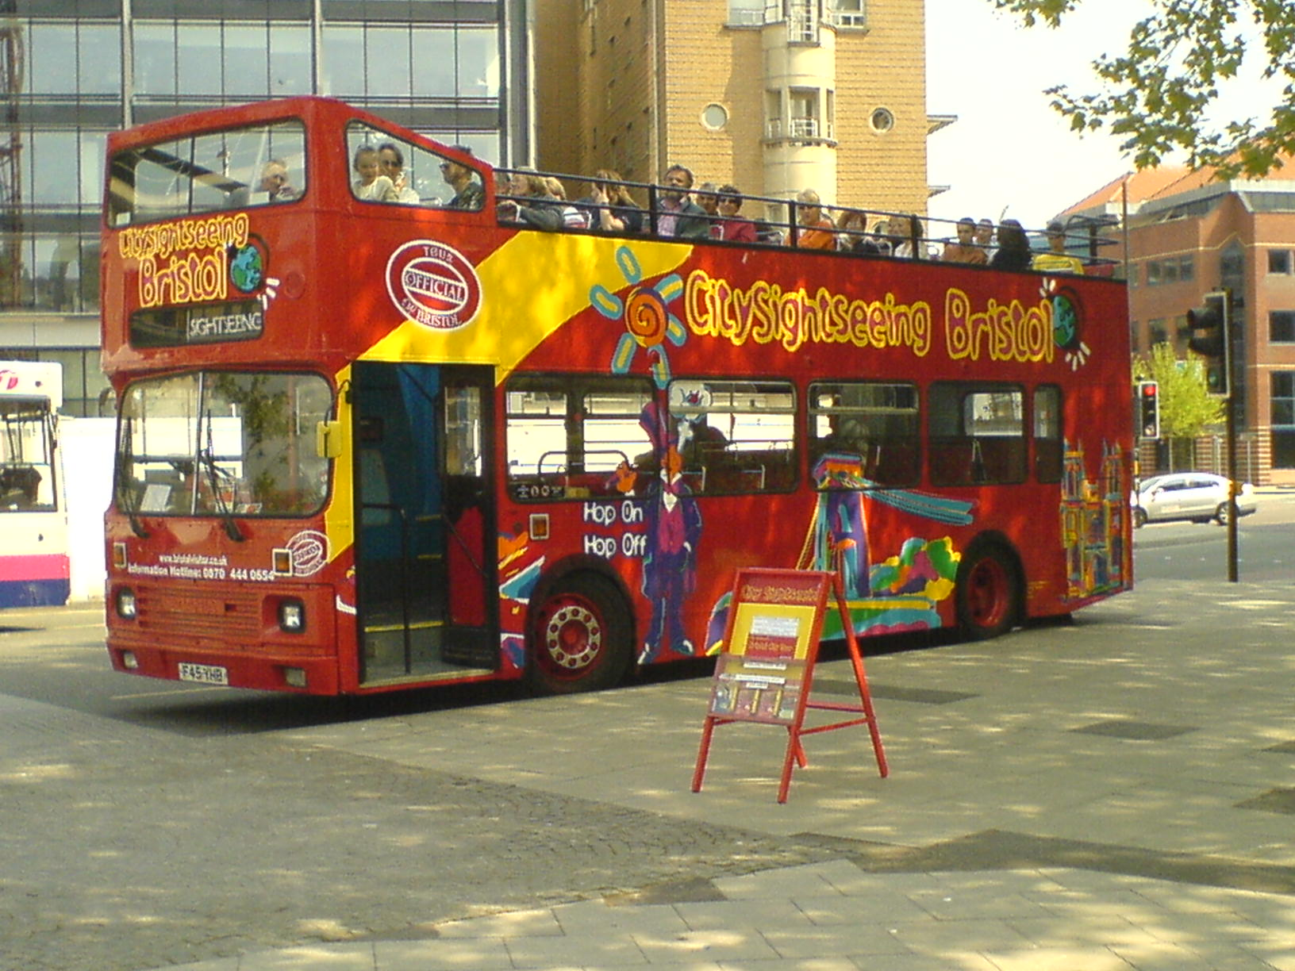
Rolls Royce Heritage Museum Trips
Available for private group bookings by arrangement. Open Top Bus trip to Rolls-Royce, Patchway with 45 minute guided tour their Heritage Museum.  Collection of aero engines from Rolls-Royce and its corporate predecessors. Extensive collection of literature, images, films and models is on view. Also examples of the 390hp Bristol Jupiter to today’s Eurojet EJ200, the famous names of radial engines, such as Jupiter, Pegasus, Mercury, Hercules and Centaurus as well as gas turbines from Theseus to Olympus, Pegasus, EJ200 and JSF engine components.  £15 per head for groups of 20+. Maximum group size of 27 people. We regret this trip is available to aeronautical enthusiast groups only. | 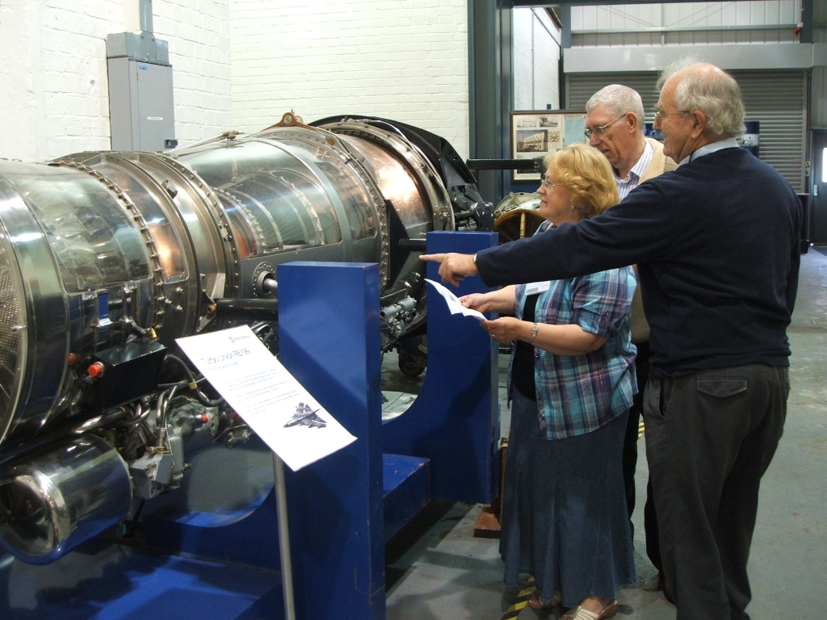
For further details and bookings on both trips please contact:  Nicola Padden, Corporate Sales Executive, City Sightseeing, Bristol.  0117 367 0208 nicola.citysightseeing@yahoo.com  www.citysightseeingbristol.co.uk |  | 