My Student Apprenticeship at
The Bristol Aeroplane Company

April 1946 to April 1951

Norman Gardner, MSc, PEng

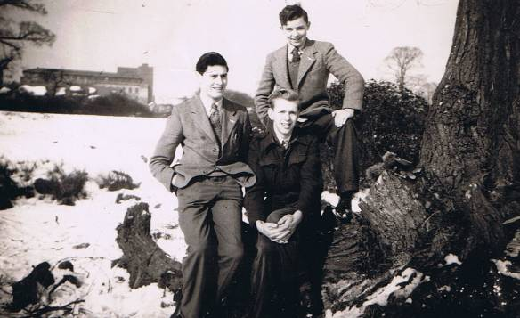

Norman Gardner (left) at Filton with John Burleigh (top) and Bob Hayter, 1946
New Filton House is in the background

Article written in March 2009
At Penticton, British Columbia, Canada

Chapter 1- Introduction

This article covers my engineering apprenticeship with the Bristol Aeroplane Company from April 1946 to April 1951 which is fully detailed in the following text. At that time the Bristol Aeroplane Company was the largest fully integrated aircraft and aero engine company in the UK and possibly Europe.

Chapter 2 - How I Joined the Bristol Aeroplane Company

I was born in 1929 and grew up in a mining village in County Durham far removed from Bristol. At the age of 11, with the war just started, I passed the 11+ examination to enter the Consett Grammar School where I did particularly well: winning on graduation the school prizes in math’s, physics and art.

The book I received for the prize in physics was titled, presciently, “Tomorrow’s Airliners Airways and Airports”. I always had a fascination with aeroplanes and in my early teens was a member of the Royal Observer Corps and the Air Cadets. I had some propensity for leadership becoming a sergeant in the Air Cadets - I was a sixer in the Cubs during my elementary school time.

As a teenager, I attended several summer camps at Royal Air Force stations which I gave me an exciting introduction to the incredible world of wartime aviation. I remember being fascinated by the many training aids including those for the early radar systems and for aircraft electrics and hydraulics.

I happened to be at a spring Air Cadet Camp at an RAF station (Finningly, I think) when the war ended on April 8th 1945. The euphoria of that day and night was amazing for a boy of 16 and the events would be worthy of a separate account. The relevance here is that the end of the war came just before I gained the Oxford School Certificate with high rankings. I then moved to the Higher School Certificate class and had pressure from the Headmaster to choose an academic career – this would have meant University as a first step for which funds were not available.

Instead, I found an advertisement for Bristol Aeroplane Company apprenticeships in the Air Training Corps Gazette, to which I subscribed. I sent off the coupon and received a brochure called “The Training of Engineers for the Aircraft Industry”. This brochure is still in my collection of records. After a short review of the history of the British aircraft industry and Bristol’s prominent part, it inspired with me with the following words,

“Great as the developments have been, the problems to be solved by Engineers of the future will be even more far-reaching, and an inspiring career awaits the young man who takes up the profession and receives a thorough training in all its branches.”

It went on to specify the type of candidate being sought,

“The desire to attain a position in Aeronautical Engineering must carry with it a natural interest in aeroplanes and a good general education. These are the foundation stones on which, with workshop and technical office experience, a successful career can be built up.”

Surely, I thought, that is me and decided to apply. Soon an invitation to attend an interview at Bristol was received. My parents and headmaster gave their blessing and I was fortunate that one of my teachers hailed from Bristol and arranged for her parents to provide two nights accommodation for me.

Of course a trip to Bristol from Newcastle is no big deal now. But in 1945 it was an arduous 14 hour steam train journey. My hosts in Fishponds provided generous hospitality, including an evening playing records of high opera. I travelled around on Bristol buses which were plentiful and cheap. On the way to Filton there was a Bristol Freighter prototype flying overhead – it was probably the first Bristol aircraft that I had seen in flight

I don’t remember the interview in any detail but must have made a reasonable impression because I was soon asked to report for the six months probationary training in the Instructional School at Southmead (on 29th April 1946) to be followed by a Engineering Apprenticeship extending to 27th April 1951. Thus I left the grammar school in spring 1946 and left home to start my new life in Bristol.

My first digs were on Filton Road near to the cinema. They cost two pounds a week and my pay was only one pound 11 shillings and six pence so my parents supported me those years with a hard found pound a week. I lived a Micawber existence like the rest of my companions: the lack of money saved us from smoking and other vices and we lived happily, content with our lot.

Bristol in 1946 still had extensive bombing damage in the central areas a fact immediately obvious when I arrived at Temple Meads station. The bomb damage was still evident when I left in 1952. Food and other necessities were still rationed and would be until about 1954. But the city had an appealing vibrancy and I loved the Downs and the Clifton Gorge with Brunel’s magnificent suspension bridge.

The BAC premises were awe inspiring and seemed to go on for ever. I came to know and admire all the workshops at Filton and Patchway, the design and production offices, the row of converted cottages that housed the doctor, the Chemistry Department and the Architect, the huge Work’s Canteen at Filton, the Recreation Pavilion at Southmead, the airfield, and all the rest that made up the great enterprise. Strange to think that it seemed so developed and settled yet only about 40 years had passed since its founding. Now we will celebrate the 100 years anniversary in 2010 with many of the buildings demolished or abandoned and the Bristol Aeroplane Company business name gone.

Chapter Three – At the Southmead Apprentice Technical School.

The transition from sheltered home and school life to the world of industry was eased by the initial period at the Technical School. Nevertheless; the strange environment and getting-up and starting work at an unearthly hour was a shock. One major change for me in the digs was the encounter with Bristol hard water in a bath heated by a gas geyser - I had always known unlimited, silky-soft hot water.

I am reproducing some photographs taken from the BAC brochure, below, showing the Technical School in action. The quality is poor because they are scanned from low resolution photographs

There were three full-time instructors well chosen from the “works” headed by the chap in the background of the first photo. In the foreground is Bert who was deaf. He had a first generation hearing aid with the battery pack, microphone and amplifier carried in a large pack on his chest. A favourite, typically cruel sport of us teenagers was to talk silently to Bert with our mouths moving to get him to frantically slap the chest pack thinking that it had failed. The instructors were very competent, friendly and wise. We all had a crash course in metal work on the bench, the press, on milling machines and the lathe. Another instructor covered electric wiring and taught invaluable, practical design approaches. The school had a Beaufighter fuselage which we stripped and rebuilt. We also found a tiny closed space just before the tail in which we crammed like sardines as a lark.

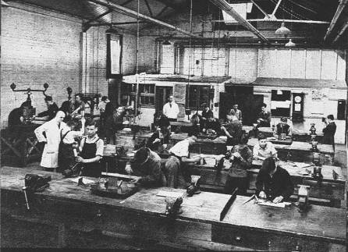
The Fitting Shop at the Southmead Technical School

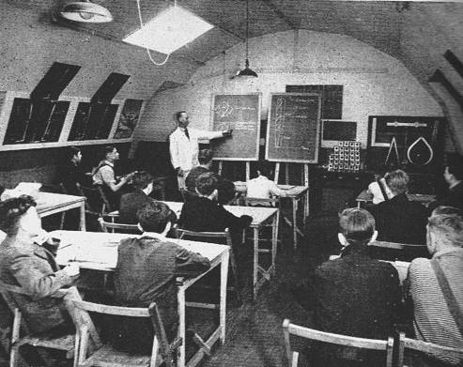

Lecture Room at the Technical School - How young we were!

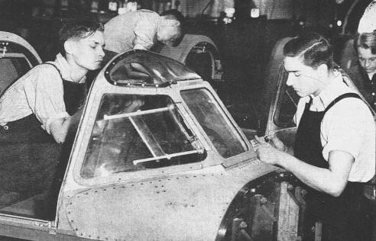

Apprentices Tinkering with the Beaufighter

We also had classroom instruction at a school at Patchway. This was approached through an engine assembly shop in which the massive Centaurus 18 cylinder sleeve valve piston engines in two banks were being assembled. It was a very different world to the aircraft factory up the hill.

I cannot remember if we were enrolled at the Merchant Venturer’s College near to Bristol Centre during our initial training. However, a one-day-a-week course designed to lead towards the Higher National Certificate in Mechanical Engineering was a key part of the total apprenticeship program. Here is a photo of the old Merchant Venturer’s college in Union Street which was founded in 1595.

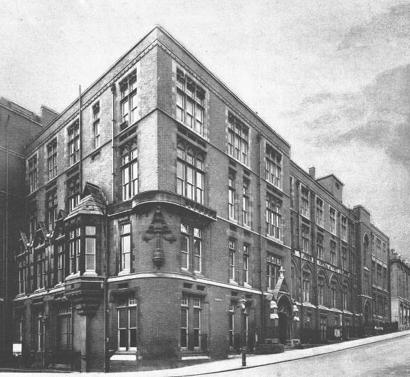

The Merchant Venturer’s College in the mid 40’s

Chapter 4 – The Departments I Served

Soon it was time to start the apprenticeship proper and we were assigned to our first shops in the main Filton works for subsequent rotation to other departments.

My first department was the Machine Shop housed in a large shed near to the Main Gate. There were extensive banks of turret centre-lathes, milling machines and fascinating automatics. I was able to work on each type of machine during my six month sojourn, including the automatics. The machines were programmed and tooled by very skilled machine setters so that the machine operating tasks were really a human extension of the machine and we went as fast as the machine set-up would permit. I always tried to be the first operator to switch on the machine when the shift start signal sounded – to do so earlier would have been a grave transgression of worker ethics. The parts I made were mainly for aircraft but Bristol’s also performed work for outside companies. One job I did was to machine spindles for the Vincent Black Shadow motorcycle front forks and I have had the pleasure several times in my life to locate the spindles on Black Shadows in museums in Canada and America.

My time on the automatics was a special favour from the Machine Shop Superintendant after repeated badgering. The section was handled by only one man who did all the setting-up and operation so all I really did was to observe and learn. These machines turned out small parts by the thousand and were a revelation to me of the power of designing special machines which could endlessly produce parts without too much human intervention. Of course, such machines are far more versatile today. I saw a batch in a factory in Switzerland about twenty years ago producing minute watch parts. The smell of the cooling, cutting fluid immediately took me back to my days in the Bristol machine shop.

Next I was sent to the a Fitting Shop to work on a bench producing short runs of the multitudinous parts made from Duralumin needed for the internal aircraft structure; such as stringers, clips, covers and the like. For most parts we were supplied with drawings, templates, jigs, and in some cases with cut-out blanks but some parts had to be made from scratch from sheet metal to drawing. One useful skill taught at the Technical School was to be able to calculate the allowance in size of parts that had to be bent over a radius. Not all the regular fitters could do this and I achieved some sort of standing in this art.

The men on the benches had been there for years and must have been bemused by the presence of young apprentices who needed all the help they could get. And such help was readily forthcoming because to their credit we were accepted as part of the workers’ fraternity. I particularly remember one act of kindness when I stupidly sent some blanks I had made for solution treatment prior to bending. The bend radius did not need solution treatment, a process for temporarily softening aluminium, and my blanks came back hopelessly distorted. A worker near to me saw my distress and with a few expert blows with a soft hammer restored the parts so that I was able to finish the job to the satisfaction of the inspectors who rigorously checked and stamped every part.

Other memories taught me respect for the factory worker and to never underestimate them. For example, I heard a piece of classical music on the radio one evening and next morning hummed the opening phrase to a neighbour on the bench saying that I wished I knew what it was called. He immediately told me it was Mendelssohn’s Italian Symphony and detailed the structure of the music for me. Perhaps such knowledge was symptomatic of the age without television and before rock-and-roll.

Later I was also most impressed by the ability of the workers to calculate the time they could charge to a job without incurring a bonus penalty if it went too fast or slow – for a team building a complex structure like a wing this was an amazing mathematical feat. I learned early on that in an industrial environment the management does not always know what is really going on at the shop floor. In an era of rationing there were always chocolate bars for sale from a case under a bench which had obviously “fallen from a lorry” - not that I could afford to indulge.

Ingenious ways to pinch things and get them safely through the Main Gate were always being found: an example was the character who took into the works the head and feet of a turkey and a large sheet of brown paper at Christmastime and left with a bench vice rolled up in the paper with the legs and feet protruding, declaring successfully at the gate that he had won the raffle. Such basic object lessons in shop floor abilities and ethics learned on my apprenticeship were useful to me in management in later life!

My next move was to the wing assembly shop where wings for the Freighter were being built and a large number of wings disassembled from completed Brigands were being up-graded. As the lowest of the low I had to do a grueling stint working under the wing drilling out rivets which were being replaced by larger diameter rivets. Apparently, the stresses on the fighter were so high in certain maneuvers that rivets popped off. We diligently drilled out the 1/8 th rivets and put in 5/32 diameter but I was doubtful that this tinkering resulted in a stronger, tight structure. Years later I was in Singapore with the RAF and learned that several Brigands were lost unaccountably over Malaya and wondered if they had some of the wings which I had helped to modify.

This was my first experience of being part of an assembly team. The Team Leader was a working manager for the group and allocated the tasks as he saw fit within broad time parameters fixed for the job by the Production Office. As already observed, the Team Leaders always sought to maximize the team bonus by finishing just short of a time when the job would have been re-costed.

I was then sent to the Experimental Shop – a plum posting. This shop occupied a large hangar at the top of Filton Hill. There were many rows of benches; some machine tools including the ubiquitous wheeling machines for producing double curvature fuselage panels; and plenty of space for assembly of wooden and metal aircraft prototype structures. This place was able to speedily turn out almost any structure or system required and naturally was manned by very skilled, experienced people. I had the good fortune to be placed with John Jago who could make anything and was a great teacher. Not only that, he introduced me to his home and especially to his brother David of whom more later. I was involved in many jobs and remember particularly assembling the gear boxes for the Freighter door opening system involving a lot of hard hand-reaming of holes for the closely fitted bolts.

The Experimental Shop was a law unto itself. Each bench was customized individually by the long standing occupants with tool racks and decorations such as photographs – but not centre fold pictures which did not exist in those more correct times! Many of the benches had electric heaters and hot plates built-in. It was usual for hot food to be prepared at morning break – even full English breakfasts. The Shop Manager, Bert Clatworthy I recall, was never reconciled to this and stamped around looking like thunder. I remember him enquiring at one bench, “Is this all you bloody well have to do?” which provoked the response, “No, we have more eggs and bacon to cook when this is finished!”.

I did not appreciate then the caliber and long service that people like Bert Clatworthy had at Bristol’s and especially their role in the pre-war and wartime build-up of production capabilities. I was fortunate to be at Bristol’s when such characters, using the term in a most laudatory way, were still around.

The wooden prototype for the Brabazon and a functional mock-up of the control system were on the shop floor during my time there. There was also a smaller scale wooden cut away model of the Brabazon showing its spacious unrealistic cabins complete with a small area for stand-up socializing or dancing. The design was due, I understand from later reading, to BOAC’s incompetent advice and to designs being from a high price London interior designer. Compared to modern aircraft with much higher passenger numbers, the Brabazon interior had many toilets. The small wood model reproduced the toilets, each complete with a small wood toilet seat. These we “requisitioned” and used as under the label badges for an exclusive Harpic Club with the motto, “clean around the bend”.

A Bristol Freighter was prepared for a demonstration trip to South America while I was at the Experimental Shop and we had a naming ceremony before I helped to push the aircraft outside. We were all shocked and upset when the aircraft was reported lost by ditching in the South Atlantic. Apparently, the pilot had been given a 180◦ reciprocal bearing for wind direction which had taken the aircraft off course until it ran out of fuel. I once had the unhappy experience of being in an RAF aircraft lost for an hour over greater London due to the same cause. The loss of the Freighter was a set back to Bristol’s at a time when not much was being produced at a profit.

I was now half way through my apprenticeship and I was transferred me to a small Development Engineering Group located in new Filton House. This was a great opportunity and I had the added advantage of staff hours. I finished my service there as an apprentice and then as a Junior Development Engineer, contentedly involved with creating cutting-edge airframe technology.

The Chief Development Engineer was Harry Pollard of great fame as a leading British aircraft engineer. His great achievement was the development of stressed skin metal aircraft structures in the 30’s. He was a big man in all senses and had joined Bristol’s in 1923 coming from Boulton and Paul, leading early aircraft manufacturers. He was in charge of the Filton Aircraft Development Department during the mid 30’s and was very involved with the expansion for the Britain First project. He was appointed General Works Manager at that time. His office was remote in old Filton House. He drove a beautiful 1934 Bentley Car that I have since learned he bought from Sir William Verdon-Smith for ₤475 in 1940 and which still exists. It was for sale recently at £39,000. Here is Harry Pollard’s old car:

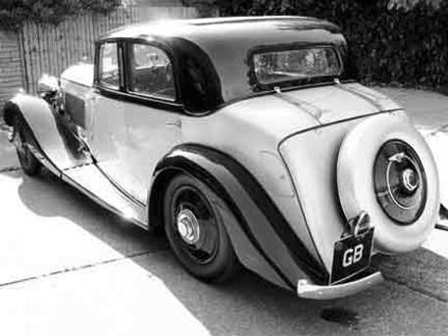

1934 Bentley 3 ½ litre Derby Park Ward

By the time I joined his team, Harry Pollard was “getting on” but was obviously well connected and his name and the Development Engineering Department carried high associated prestige. The second in command, was Freddy Parker with whom I had more contact. He also, incidentally, owned a vintage car and brought it regularly to work. My immediate supervisor was John Cotes who I met again later in life when asked me to consider a job at Hawker’s - which I declined being committed to emigrating to Canada. John Cotes was an intense but friendly chap, with good all-round engineering talents. Some wag had fixed a typed slip above his desk containing a quote from Oliver Goldsmith’s, The Deserted Village: John did it not take down!

“And still they gazed, and still the wonder grew, that one small head could carry all he knew”

The development group was housed in New Filton House. I was given a prime desk position at a window on the second floor overlooking the Main Gate. Here is a photo of the building in its pre-war glory showing my location – the building was less spectacular then in its wartime camouflage paint.

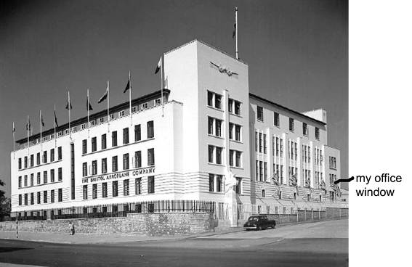

New Filton House before it was Camouflaged

We did the office related work in New Filton House and used the works departments as necessary for experimental prototyping. I enjoyed the freedom to visit and use all the design, production and production departments and gained an encyclopedic knowledge of the total capabilities of the Bristol enterprise.

In time the “development workers” office was enlarged with several other apprentices and some permanent staff members but I had leadership responsibilities for projects assigned to me and could call on support from the team.

Our work concentrated on the development of the fabrication of new aircraft structures in metal and composites. We were certainly ahead of our time, particularly in metal-to-metal bonding, and in composites. In Canada, twenty five years later as the Canadian Director for Aerospace, I found myself having to initiate industry projects to catch-up these technologies.

Metal-to-metal bonding was a pet project of Harry Pollard and he secured the necessary government funding for our extensive development work. By the time I arrived an autoclave installation had been set-up in a fitting shop near to Heat Treatment. My first task was to document the process which formed part of the report to Government. The Company Photographer was on call – a likeable, very competent individual who never wasted a photographic plate and always turned out the photographs I needed. Hopefully, the historic library of photographs that existed then has been preserved.

This is a picture of me taken with the Autoclaves in 1951. It is from the RAeS journal account of a lecture on Metal Adhesive Processes by Freddy Parker which I helped to compile. I was 21 at that time, nearing the end of my time at BAC.

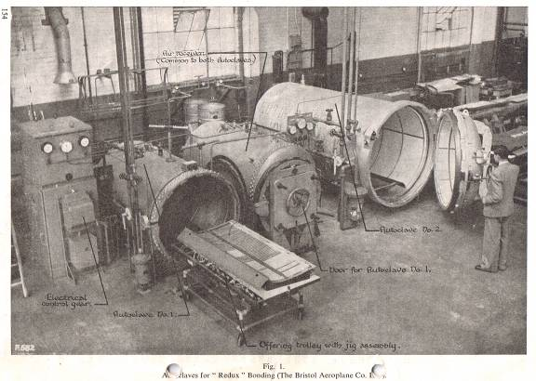

The Redux metal-to-metal bonding process was used extensively in the Britannia Aircraft which was started during my term but really belongs to the era after I left. My contributions were concerned with developing the tooling for autoclave fabrication and with the development of reproducible non-destructive means of testing the finished product.

I was heavily involved with early work on fabricating composite structural components from fibre-glass and resin. I had the help of a skilled worker assigned to me at the Plastic Shop. He had an interesting background: before joining Bristol’s he had manufactured radios in plastic globes at his own company but had gone bust. Together we did instrumented layups and once made a memorable visit to RAE Farnborough together to use their testing services.

This Farnborough visit gave some additional experience which was useful in later life. On arrival at the Farnborough Main Gate we were told that we would need security clearance to enter. I asked how such clearance could be gained to be told that I had to see the Security Officer – I was then sent inside the establishment, unescorted, to the Admin Block. I found the Security Officer on the telephone. Without stopping his telephone conversation he raised his eyebrows and I mouthed that I needed two security passes. Without any questions, and still telephoning, he signed two passes and handed them over. In the mid 70’s I was on a visit to the UK and learned about a pending restricted conference at Farnborough on remote piloted vehicles. There was no time to obtain an advance security pass and I was advised by the Canadian High Commission in London that I would not be allowed into the RAE. Needless to say, with the benefit of my Bristol experience with Farnborough security, I was able to gain admission and attend the conference. To my delight, one of the attendees from British Industry was Reg Austin, a fellow Bristol apprentice.

I also did early development work on processes for fabricating parts from Durestos, a flexible asbestos/ phenolic resin sheet material, which was polymerized by heat and pressure. The air conditioning ducts for the Britannia were made from Durestos. This material was also used for wing-mounted fuel drop tanks which were produced in large numbers by Bristol’s during the 50’s using our processes. Concerns about the possible harm from using asbestos were swept aside by the belief that the asbestos/phenolic combination in Durestos was harmless. We did some wing development work in Durestos during my time for a secret cruise missile project, which became the Bristol 182 (but made completely in metal), before the project was cancelled in the 50’s.

As mentioned, my structural plastics experiments were carried out in the Plastics Shop which was ruled by a tyrannical, dogmatic Welshman whose name escapes me. One day I had a disagreement with him on the design for a jig to apply equal circumferential pressure during curing – he insisted on a modification which I knew would not work and when I stood my ground insisted on us going together to see Pollard. To his credit, Harry Pollard backed me up but things were strained for me in the Plastics’ Shop thereafter.

Another area receiving my contributions was helicopter blade fabrication. Bill Baker, who went on to be a leading person at Bristol Plastics, was the design engineer in the “Odeon”. I remember him always calculating, in those days before the availability of computers, with a massive columnar slide rule. Once, a short section of helicopter blade to a new design was made and a way had to be found to dull the surface to reduce reflections. I was asked to take the blade in a wooden box, about 5 feet long, to a company in Manchester for surface treatment with a new process called Vapour Blasting. I jumped at the opportunity and travelled to Manchester by train, then by bus to the vapour blasting plant.

I stayed in at a hotel in downtown Manchester. It was raining very hard but I went out in the evening to explore. By chance, I found a Hallé Symphony concert, to be conducted by Sir John Barbirolli, at the Manchester Free Trade Concert Hall. At the box office I found that the half crown coin, which was all the money I could spare from my meager expenses, was inadequate to buy a ticket. The Ticket Seller took pity and directed me around to the back door where someone would let me in for my half crown if I told them that Sid had sent me. In fact, when I told the guy at the back door that Sid had referred me he let me in for nothing. The main music was Brahms Violin Concerto which has been a favourite for me ever since.

The next day, lugging the precious box, I decided to take a short diversion across the Pennines to visit my married sister living in Sheffield. When I arrived, naturally, the family wished to see the specimen helicopter blade. As soon as I opened the box, their kitten jumped in and walked the length leaving a trail of paw marks. I visualized my apprenticeship at BAC coming to an immediate end. However, the treated surface was restored with careful application of a damp cloth and no one was the wiser at Bristol. I even had a commendation for rendering such a good service and for not spending much money.

An individual project of mine was to research better riveting methods, particularly to achieve better wing smoothness. The standard method of setting rivets in those days was derived from the traditional way of shipyards – to have an impact hammer on the outside and a bucking bar held by an unfortunate worker, without hearing protection, inside the structure. A good team could work very fast and effectively but there was great variability in the quality of the set and the outside finish was poor due to the protrusion of the rivet heads. A starting point for improvement was Chobert Riveting (from America) which set the rivet by pulling a mandrel through the rivet from the outside. The mandrel was then sheared so that the plug remained in the rivet. There were drawbacks since the faying surfaces of the skin and the underlying members had to be exact and the protruding mandrel had to be machined flat. There was also a high cost to import the rivets.

I redesigned a complete Bristol range of Chobert type rivets. They were initially machined by hand in the Machine Shop from a block of Duralumin. We also improved the final milling tool for taking off the mandrel and any head protrusions. When all was complete and proven, John Cotes opened negotiations with a British manufacturer, Avdel, to take over production of the rivets. He and I went to London for the final negotiations which were held in Scott’s Restaurant, then in Piccadilly Circus. I remember being shocked at a bill for four people for a four course dinner totaling £7 – well over the Bristol allowance but Avdel’s paid!

Around this time, for constant improvement of finish and ease of assembly, Bristol’s started to build aircraft structures from the outside in, starting with a formed skin held firmly and building the support structural elements inside. This was a reverse of the traditional way. The change facilitated the use of Avdel and other machine riveting and was needed to pave the way for the use of metal-to-metal bonded structures and later composite structures. Even so, the finish on British aircraft remained poor into the 1950’s – I was at RAF St Athan in 1953 when the first Sabre Fighters built at Canadair, Montreal, arrived and was most impressed by the superior surface finish achieved in North America.

There were many approaches to BAC from outside places for “grace and favour” non-aero projects. Our Development Engineer’s office was a resource centre for many of these requests. For example, we designed and made one of the first artificial kidneys for the Radcliffe Infirmary, Oxford. For design input, I had to ask the resident doctor at Filton for data on the blood content of humans but he did not know the answer! In fact, the capable Nursing Sister did most of the real medical work at Filton and was the source for the answer. The cost of the artificial kidney was lost in the accounts for the Brabazon project. In other words it was what we called a “foreigner”, like the many lighters, pens and other artifacts made illegally which graced many workers pockets. The making of “foreigners” was not restricted to the lower orders. One time, Freddy Parker asked me to have a new centre hinge strip made for his car in stainless steel, a rare and costly material those days. I had the 4 foot strip made courtesy of the Supervisor of the Rolling Mills Shop who was a friend of Freddy. It required specially made rolls, no doubt paid for by the Brabazon.

The first Brabazon prototype was sufficiently complete by December 1948 for the company to hold a roll-out ceremony at the new Brab hangar. I attended this roll-out. The first flight was delayed until 4 September 1949. I was part of the throng on the north side of the runway on the day of the first flight and took this photo
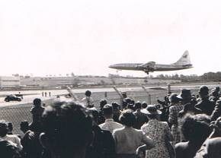

Brabazon First Flight 1949

The crowd was ecstatic at seeing the Brabazon fly because there were great hopes that it would lead Bristol’s into a golden future – as we now know the project was already doomed by more practical aviation advances in the USA.

As an aside, I escorted many official visitors to see the Filton works and always finished up in the Brab Hangar where the following photograph was taken showing the large size of the aircraft. I am 3rd from the left at the back row. Bristol’s always gave VIP treatment to visiting RAF officers because they could influence aircraft purchases. For example, when I visited the company in the mid 50’s as an RAF Officer, I received an executive welcome and lunch in the Director’s Dining Room on the top floor of New Filton House.

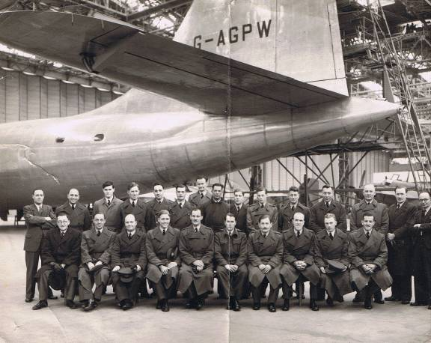

RAF Officers Visit to the Brabazon Hangar

Returning to technical matters, strangely, we were active in pre-fabricated housing design for residences required by the then British Cameroons in West Africa. A colleague of John Cotes did the basic conceptualization of the wall modules and the design of an ingenious connecting bolted assembly. I do not know why we did these designs at Filton; presumably by then the Weston pre-fab design teams had been disbanded. The building modules were manufactured in a Filton shop and then shipped to Africa. To meet the shipping deadline a foreman assembler worked for three days non-stop. Sir Stanley White and Harry Pollard came to the shop to see the finished product. When told of the herculean effort by the foreman Sir Stanley’s only comment was, “Think of the bloody money he is earning!”

Freddy Parker went to the Cameroons to supervise the erection of the buildings. He took with him a miniaturized set of drawings and motivated the uneducated native workers by giving each a drawing. The foreman who had worked on the buildings at Filton also went to the Cameroons and stayed there, possibly for many years. He sent back regular instrumentation readings for us. However, this project did not result in further sales. When Freddy returned, I helped him with his report and illustrated it with a map of Africa showing his travels. To get the map to fit the page I squeezed-up the west coast and then realized the vastness of that continent since I had reduced its width by 1,000 miles. I also included a photo of the natives eagerly receiving their drawings but, regrettably, do not have a copy to post here. Freddy Parker sadly died shortly after I left Bristol’s from a bug he picked-up on a holiday in Spain.

We were also associated with housing for the Groundnut Project in East Africa. The Groundnut Project was a last gasp grand British colonial effort and eventually failed. Bristol’s part was to come up with a cheap Kraal-type building using metal since the usual native building materials were in short supply. We designed a no-frills octagonal structure out of brake-pressed aluminum sheets, with simple cut-outs for windows and doors. We had serious discussions on pee-proof paint primer. Many hundreds of these panels were made. I do not know how many of these Kraals reached Africa; but to my astonishment, in 1953, I found myself housed in one as overflow Officer’s Mess accommodation at RAF Colerne. My kraal was insulated and had doors and windows, so someone had found an entrepreneurial way to market the redundant product.

The largest extra-mural project for our group was the design of the first floor seating units for the Earl’s Court stadium in London. The seating units had to be able to raised-up by hydraulic rams to accommodate exhibits for trade shows. The hinging of the large seat units posed very challenging design problems since the building was nearly a quarter mile long and far from even and flat. This meant that every seating unit hinge position had to individually customized. The design was supervised by John Cotes and was handled by our team of apprentices assisted by two senior draughtsmen. Our team was housed in an elegant sheltered room in Old Filton House remote from aircraft work. A firm of London based structural engineers provided structural engineering certification. I was peripheral to the project but always kept well abreast of our projects.

All the seating units were designed and built to aircraft dimensional standards of +/- 10 thou which was the only standard the shop workers knew. This was an early lesson for me that aircraft companies cannot really reduce their accustomed standards in order to serve, profitably, the commercial building market. By contrast, the company which made the mobile ground floor seating units cut and assembled the structural members to chalk drawings on their assembly shop floor. Consequently they made money on the project and Bristol’s did not. We had a large cost overrun. At the end of the project I was with John Cotes when we went to the Advertising Manager in the Bristol Sales Department to enquire about publicizing our seating of which we were all very proud. At that time Bristol’s advertized on the whole back cover on the Flight and Aeroplane Magazines and we thought that an advertisement for the Earl’s Court type seating could be displayed there. We were shot down when the manager asked, “How many more such seating units do you wish to make?”

During my time in the Development Engineers Department there was a gradual transition from being a mere apprentice to becoming a Junior Development Engineer and in my last few months I had full staff rank.

I could go on with reminiscences about the activities in the small, dynamic Development Engineering group while I was there but have said enough to show the variety of challenging engineering work. What a marvelous exposure to aircraft engineering for me in my late formative teens! The Bristol Aeroplane Company certainly lived-up to the promises in the brochure that induced me to join.

Now I must cover some wider general aspects of being an apprentice at Bristol’s in the immediate post-war period.

Chapter 5 – Life Generally

Like me, most of the apprentices were away from home and lived in digs. Some stayed put at one place for their whole apprenticeship period. For myself, I was ever edgy for a move after a few months and I had several locations before eventually moving to a self contained basement flat In Henleaze for my last year or so.

My moves sometimes were shared with friends, like Doug Jones with the Pike’s and with Geoff McQueen at Mrs Chard’s. Mrs Chard had a house overlooking the Gloucester Cricket Club grounds and we could watch the cricket matches from the back windows. At one time I moved to be a lodger in a house owned by a butcher with a shop near to the Downs, with the expectation that the food would be superior – to my sorrow I learned that butcher’s families eat the cuts that no one else wants. There was a period when I sought the rural scene at a guest house at Littleton near to Thornbury. This move failed because I had to get-up very early, in the dark, to walk across fields to catch the bus at Thornbury and equally found myself returning at dusk hungry and tired. Sleep there was made difficult by the incessant hooting of owls. Despite the elegance of my surroundings and the good hospitality of the two young women who ran the Guest House, I soon escaped back to the Bristol Aerial - as the local’s pronounced it. Geoff McQueen and I had a very enjoyable period staying at the Lodge at Blagdon (I will be describing the Lodge later) travelling to and fro on his motor bike. The roads were not congested then and we always made good time on the journey through Bristol city and the Somerset countryside. My Henleaze flat was my best accommodation, giving me the freedom of my own place although a drawback was to do my own catering. The upstairs flats were occupied by the Landlady’s family and by two young female teachers. I had limited interaction when moving through to exercise my weekly bath privilege in the upstairs bathroom!

Our lives were enriched by membership of the ACES Club, established by the enlightened BAC Board for the apprentices and for other more mature groups like the ACES Motor Club. ACES (I believe) stood for Arts, Culture, Education and Social so it had a wide and flexible mandate. Two outstanding individuals ran ACES from an office on the ground floor of New Filton House, Mr. Ashford (Ash) and Mrs. Smoothy. I was told that in an age of segregation between males and females at work, the BAC Board had given special permission for Ash and Smoothie to share an office. I cannot speak too highly about the selfless and generous contribution that Ash and Smoothy made to our well being both at work and at play. Mrs. Smoothy was also the landlady of John Burleigh, a good friend of mine.

ACES organized many events that drew us together as a friendly group such as great treasure hunts lasting hours as we trekked through Bristol on foot following the clues. There were also ACES dances which introduced us to the girls from various BAC offices.

The most important ACES activity as far as I was concerned and of which I was a founder member was the ACES Caving Club. The leading people were Peter Stewart at Patchway, David Jago, brother of John Jago with whom I worked at the Experimental Shop and an outsider, Susan, who had a job visiting farms in Somerset to give advice on cultivation and rearing of stock. Don’t ask how this group came together! It just happened by osmosis. The motivation was the joy of escape into the countryside at weekends for a complete change with good friends; doing our thing – exploring underground, hiking around, drinking beer in the pubs at Burrington and Blagdon, being young and alive.

We found an abandoned stone built barn near to Burrington Coombe and were able to get permission to take it over as our lodgings and headquarters without charge. Permission came from Lady Wills of Will’s Tobacco fame, who owned the estate. Her Gamekeeper who lived nearby kept a friendly eye on us. Mr and Mrs. Lay lived in a modest house in the yard below the barn and we drew drinking water from their outside tap. (Many years later, Daphne and visited from Canada and found that the Lay’s were still in residence but now had indoor plumbing). Jim Lay was the farm hand for a local farmer who had a herd of Guernsey cows. We purchased milk, eggs and clotted cream direct from the farm.

We discussed a name for the barn for hours but finally settled on “The Lodge”. Then we needed a motto for the club and someone suggested a Biblical quotation, “It is better to light a candle than curse the darkness”. We had this translated into Latin and made an aluminium sign (courtesy of Bristol’s) endorsed with our name and motto for the Lodge door. Here is a photo of the Lodge:

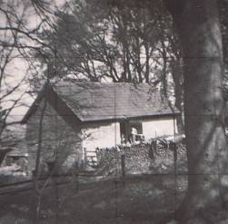

The ACES Lodge at Blagdon

The adjacent limestone gorge at Burrington Coombe has many caves all of which we visited. I almost came to grief in a very large cave in the greater Mendips, GB Cavern. I was deep underground and a ladder swung and gashed me near to my left eye necessitating a hairy return to surface and a long motor bike ride across the Mendips to see a doctor at Wells for stitches. Cave exploration was quite dangerous and when we were tired and cold underground it was tempting to take risks, especially when our limited illumination from acetylene lamps concealed the dangers. It was also hazardous boring along on motorcycles at night on the moor roads. A good friend and outstanding athlete Alan Whelpton, from Australia, died in a crash on his bike.

The pattern of the weekend was to travel by bus to Blagdon and hike in the dark to the Lodge through a beech wood. We would often glimpse badgers in the wood. We used pubs in Blagdon or at Burrington where the locals, all serfs for Lady Wills, would doff their caps at our entry and then clean us out of money playing table skittles. We caved on Saturday and on Sunday until returning to Bristol on the last bus. We slept in sleeping bags on a big pile of straw in company with many mice, but sleeping was regarded as a waste of caving time and encouraged. We always returned to Bristol happy and exhausted.

We gradually improved the utilities at the Lodge and created a built-in kitchen area. I also made a drying cupboard for clothes and boots. The Lodge became a respectable venue for parties where we entertained visitors like Ash and Smoothy, landladies like Mrs. Chard, fellow apprentices and other friends. This photo was taken at one large party:

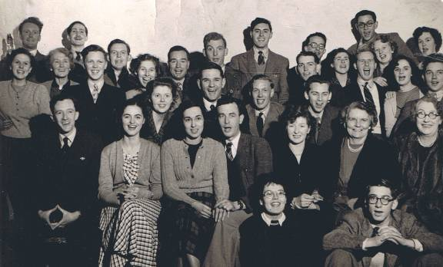

ACES Party at the Lodge, 1949

Naturally, we got up to many pranks while caving. One night we entered Wookey Hole cave illegally through the dry upper chambers which were full of hanging bats. Wookey Hole was already commercialized but not developed like the present tourist attraction. Here we are (on the next page) in the dead of night at the stalagmite formation known as the “Witch of Wookey Hole”. We occasionally liaised with the Wessex Caving Club staying at their headquarters hut at Priddy, near Wells. We adopted the Wessex Club policy of not harming caves and always taking out stuff we took in. Wells, nearby, was a beautiful, quiet city before the era of general car ownership and the resulting congestion.

The Wessex Club also taught us the trick of cooking a stew of meat and vegetables over low heat before caving so that it was ready for our hungry return – a trick which worked well until I on one occasion inadvertedly upset the finished stew leaving everyone starving and going to bed angry. Food was very scarce but thankfully, Ash arranged for us to collect, discreetly, some “surplus” sugar and butter from the works canteen kitchen each weekend to take to the Lodge.

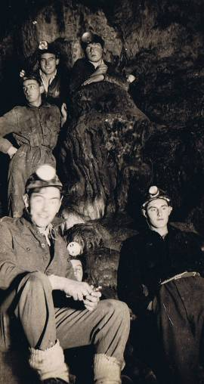

Wookey Hole – from top: ?, Alan Whelpton, David Jago, Peter Stewart, N. Gardner
Another memorable ACES event was a Rag Week collection we once organized at Filton. Everyone dressed up and we trundled around several rented Hurdy Gurdies in a day of good natured fun:

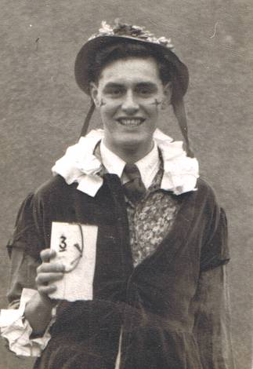

The Author at an ACES Rag Week Collection (1948?)

The Filton Works Canteen was a prominent place for everyone at Filton. Its prime role was the serve cheap, nourishing food at lunchtime. There were also several private commercial restaurants on Filton Road providing conveyor-belt cheap meals. These restaurants were a godsend because food was very scarce elsewhere. Our landladies had great difficulty in keeping us well fed. Of course, one still needed money to use the canteens and in my early years at Filton I was frequently hungry due to lack of funds.

The Filton Works Canteen was also used for work’s gatherings, for example, as the venue for work’s dances. Here is a BAC photograph of one such dance showing me, Bob Hayter and John Burleigh with lady partners near to the front on the mid left. (It would be interesting to know how many others are recognizable and still around).

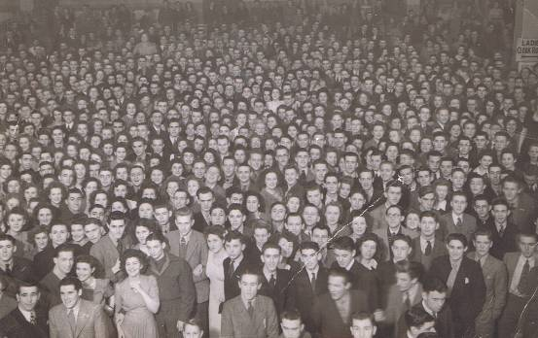

Dance at the Filton Works Canteen (1947?)

I attended a work’s gathering at the canteen in 1951 at which Verdon-Smith spoke about the Britannia project and its crucial importance to the company’s future. He exhorted supreme effort from everyone to assure success. Unfortunately, due to the late availability of engines and the loss of the second prototype, the Britannia was not a success, entering commercial service far too late. But it was still a great aircraft and gave good service commercially and with the RAF; and in Canada as a maritime derivative, produced at Canadair. I have good memories of the Britannia from the time when I had charge of the airfield at Changi, Singapore in the late 50’s, Britannias of RAF Transport Command visited on a weekly trip from the UK. I also had the pleasure of taking several trips to and from the UK and up to Hong Kong from Singapore in the Britannia.

Chapter Six – Postscript

This is inevitably only a synopsis of everything that occurred during my five years at Bristol’s. The record would not be complete without mentioning the mass visits by special train to the Farnborough Air Show each year, organized generously by the enlightened management. I was there when the Brabazon made its impressive debut. My apprenticeship took place in difficult years where the aircraft industry had to downsize from the wartime expansion and had to find its way into a global aviation world for which it was poorly prepared. Just how far behind we were for commercial aviation was found by Freddy Parker who made an inspection trip for BAC to aircraft companies in America just after the war. I was able to see and go inside the first BOAC Lockheed Constellations when they arrived at the West Bay of the Brabazon Hangar. The aircraft had been intended for KLM and had attractive woven Scandinavian designs on the cabin bulkheads. These were stripped out at Filton and replaced by the staid BOAC décor. The aircraft was far ahead of anything available from the British industry.

During my time, Bristol City gradually restored itself, although the actual rebuilding of the bombed central areas only started in the 50’s after I left. There was the thrill of seeing the Neon Signs switched on again at the Centre. There was great Civic pride when new low walls were erected around the Centre traffic islands, using broken paving stones from the blitz as the building material. There were splendid plans for a grand boulevard extending down Parks Street through Broadmead which, sadly, were never implemented.

In 1951, we were caught-up in the excitement of the Britain-can-Make-It-Exhibition held on the South Bank, London to which a group of us visited. This was an England with a difficult but challenging and rewarding quality of life. There were few frills like cars, television, foreign holidays and the like but the people I worked and lived with were happy. Things like drugs, stabbings and terrorists were not around. There wasn’t much food and obesity was not the challenge it has become today.

We apprentices sailed through these times largely unaware of the severe stresses and strains that I now realize must have been experienced by the Bristol Aeroplane Directors and Managers to keep the enterprise together. I thought then that Harry Pollard didn’t do much, resting on his laurels. I know now, with the benefit of all my subsequent experience in Government and Industry, that he must have been preoccupied with his fellow directors in finding essential funds from reluctant and ill-informed London ministries, in the everyday tasks of keeping the business going, and in making most difficult decisions for the future course of the Company.

Chapter Seven – Leaving Bristol’s

It will be helpful to put my time at Bristol into context by supplying some very brief details of my aeronautical career in the UK and in Canada.

During my apprenticeship years I was deferred from the obligatory National Service but in 1951 I had to disengage from Bristol’s and join-up. With my Bristol experience and qualifications I was qualified for a 3 year short service commission as an Engineering Officer in the Royal Air Force in lieu of the regular two years at lower rank.

In my last years in Bristol I met Daphne, a beautiful girl who lived at Thornbury and shortly after joining the RAF we married (incidentally on the day of the first flight of the Britannia, August 16th, 1952). We are happily together after 57 years. Here is a picture of Daphne in 1950, at the age of 20. We were on a hike between Lynton and Lynmouth after travelling to Lynton from Bristol on a Campbell paddle steamer.

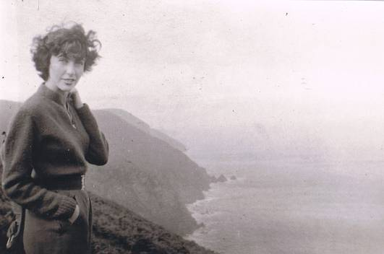

Daphne

My short service commission was converted to a permanent commission and I served in the RAF for 16 years. My time in the air force was very productive and valuable. I received extensive higher engineering and management training, including the aeronautical engineering two-year course at Cranfield, earning an MSc. I also was able to travel and serve throughout the world including Singapore, Canada and the USA and completed the Staff College course. When I was 38 as Squadron Leader I received word from the Air Secretary that I was in line for promotion to Wing Commander. But I had been offered a desirable civilian post in the Canadian Federal Department of Industry which I preferred.

So, in 1967 I left the RAF and the family emigrated to Canada and I took-up up my new position in the Federal Government Aerospace Directorate, Ottawa, charged with stimulating the industrial development of the Canadian aircraft industry. I advanced through promotions to senior executive level and became the Director Aerospace for Canada. My team was very instrumental in growing the Canadian Aerospace industry into a world class supplier of aircraft, engines and parts. Coincidentally I was also heavily involved with doing the same to create unique Canadian urban transportation capabilities now particularly evident in Vancouver and Toronto

I left this public service post in 1982 and continued my career as the President of Metro Canada International, a company with global marketing responsibilities for Canadian urban transportation products. I marketed extensively in China, Thailand and Malaya. Then, I became a Director/ engineer/ part owner of a research and testing company in Vancouver, Elemental Research Inc.

I left there to retire but was` dragged back to public service - my last formal and totally enjoyable jobs were as a senior trade counsel for the Province of British Columbia located in London, Vancouver and in California.

Our last, and current change, was relocation to the Okanagan Valley, a beautiful area in the interior of British Columbia, to grow grapes in association with our younger son and partner who have a vineyard and winery venture. We have now moved on to full retirement.

There is no doubt, that my experience and training at Bristol had a significant effect throughout my life on my effectiveness as an aeronautical engineer, as an officer in the RAF and as a senior manager in government and industry. I will always be grateful for the opportunity I had to be at Bristol's at a very formative time in my life. The practical training could not be bettered.

I have had the good fortune to develop this early foundation of knowledge, competence, and confidence during my subsequent very varied, enjoyable and fulfilling career. I made many friendships at Bristol’s which have lasted for my lifetime. I hope to meet surviving old friends at the 100th year celebrations for the Bristol Aeroplane Company in 2010.

Norman Gardner, MSc PEng
116-3948 Finnerty Road,
Penticton, British Columbia, Canada, V2A 8P8
n_gardner@shaw.ca

March 2009

